**PROPOSAL**

**Applying Personalized Learning in Gamified e-Learning to Enhance Motivation and Effectiveness in Secondary Language Vocabulary Learning**

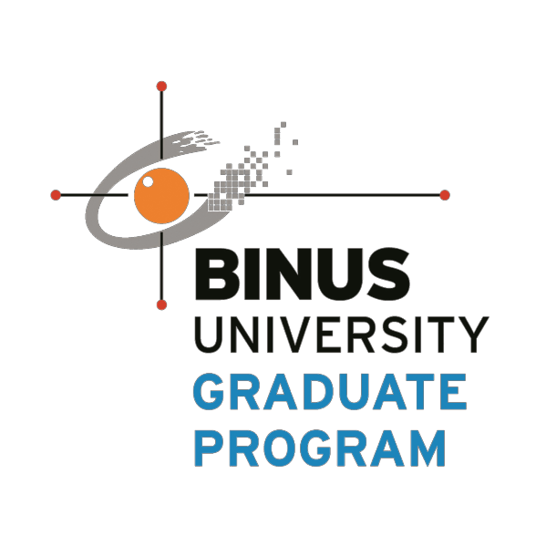

**Research**

*KANG HA SUNG*

*1901789193*

**Graduate Program in Computer Studies**

**Master of Information Technology UNIVERSITAS BINA NUSANTARA JAKARTA**

**2018**

**PROPOSAL**

**Applying Personalized Learning in Gamified e-Learning to Enhance Motivation and Effectiveness in Secondary Language Vocabulary Learning**



**Research**

*KANG HA SUNG*

*1901789193*

**1st Supervisor:**

**I Gede Putra Kusuma Negara, B.Eng., PhD**

**Date: 11 / 03 / 2018**

ii

**Table of Contents**

Cover Page........................................................................................................................................... i

Supervisor Approval........................................................................................................................... ii

Table of Contents................................................................................................................................iii

List of Figures………… ………………………………………………………………………………………………….……............ iv

List of Tables………………………………………………………………………………………………………………………………...v

CHAPTER I. INTRODUCTION................................................................................................... 1

1.1. Background..................................................................................................................... 1

1.2. Problem Identification…................................................................................................... 3

1.3. Goal of Research.……………………………………………………………………………………………….......... 3

1.4. Benefits of Research......................................................................................................... 4

1.5. Scope of Research………………………………………………………………………………………………………. 4

CHAPTER II. LITERATURE REVIEW……………………………………………………………………………………… 5

2.1. Gamification in Language Learning.................................................................................. 5

2.2. Personalized Learning…………………………………….……………………………………………………….….. 8

2.3. Motivation Measurement................................................................................................... 9

2.4. Related Works……………………..…………………………………………………………………………………….. 10

CHAPTER III. RESEARCH METHODOLOGY........................................................................... 14

3.1. Conceptual Framework................................................................................................... 14

3.2. Research Stages............................................................................................................... 16

3.3. Proposed Model............................................................................................................... 16

3.4. Evaluation........................................................................................................................ 19

3.5. Statistical Data Analysis.................................................................................................. 21

REFERENCES…………………………………..………………………………………………………………………………………... 23

iii

**LIST OF FIGURES**

**Figure 2.1.** – Gamification Elements (Zourou and Lamy, 2013)………………………..………………………… 5

**Figure 2.2.** – Gamification Principles (Healey, 2013)…………………………………..……………………………… 7

**Figure 3.1.** – Research Stages…………………………………………………………………………………………….…….… 15

**Figure 3.2. –** Hybrid Model System Flow………………………………………………………………..……….………….17

iv

**LIST OF TABLES**

**Table 1** – Big Five Personality Traits Gamification Elements………………………..……………………………18

**Table 2.** – ARCS Questionnaire (Post-Play)………….…………………………………..……………………………… 20

v

**Chapter I**

**Introduction**

* 1. **Background**

Current models of Gamification in secondary language E-learning focus on applying classical extrinsic game-like elements such as levels, challenges, point systems, and rankings to create a user interface that rewards students who complete certain assignments (Park, 2014). Popular language learning site like Duolingo has integrated ranking systems and virtual shops where students can purchase with the app’s native virtual currency. While these gamified elements may produce short-term motivation and engagement, past research has shown that external rewards tend to undermine students’ internal motivation in engaging with the learning materials (Kim, 2017). This is because once these external stimuli disappear so will the students’ motivation. Thus, the shortcomings of the current gamification model in e-learning is the lack of two fundamental factors in developing internal motivation: personalization and ownership of learning which affects effective learning outcome.

Personalization in online language learning finds learning optimization in multiple fields such as the use of language, content, context, and user interface that best suits for the students. Following one personalization learning principle, Mayer (2009) concludes that students learn better online when the computer platform uses personalized colloquial language rather than a neutral or formal language. Humanizing a computer task makes the learning experience more relatable and thus enjoyable. Testing this principle, Reichelt (2014) conducted an experiment with college students studying online and resulted that personalization within e-learning has had positive impact on the students’ overall motivation and retention.

Ownership of learning is often associated with the self-reference effect (SRE). This self-reference effect links ideas with the self and create self-processing biases to enhance memory, attention, and perception for these ideas (Humphreys, 2016). In an educational context, this effect can be a useful memory enhancer for the students as they are more likely to remember their own experiences and ideas rather than those of others (Cunningham, 2017). In their research experiment of memory recall with 7 to 9 year olds, Turk and his team (2015) concluded that having ownership of learning enhances one’s retention rate of information which greatly aids in learning secondary language spelling and vocabulary.

While current models of personalized e-learning exist such as myPTutor and Personalized Creativity Learning System (PCLS) that incorporates AI and data mining techniques to create lesson plans, they still do not offer full autonomy and personalization for the students as the computer still plays a calculating guessing factor in the direction of the learning. These models only apply guess work and does not fully represent the needs of the students using the programs. Moreover, these models do not fully apply gamification elements and focus only on the context and content of learning without creating external stimuli to engage the students.

E-Learning is still the largest domain (17.6%) of trending journal topics within the utilization of gamification (Kasurinen, 2017). Despite this, few gamification research focusses on improving students’ internal motivation by applying personalized ownership of learning that caters specifically to the individual’s interests, needs, abilities, and learning styles. They focus too much on the gamification aspects in order to produce short-term motivation for the students. However, to make a better effective e-Learning model in language learning, a combination of gamification and personalized must be applied together in harmony. Thus, this thesis aims to create and analyze a new hybrid model that incorporates both personalized learning and gamification element to create motivation to enhance the overall effectiveness of secondary language vocabulary learning.

* 1. **Problem Identification**

Having stated the problem with the current gamified e-learning model, this paper aims to answer the question:

* How can we design a better effective model that incorporates personalized learning within the current gamified e-learning model to improve students’ motivation along with learning outcomes for secondary language vocabulary learning?
  1. **Goal of Research**

The main goal associated with this analysis research:

* To create an effective personalized gamified e-learning model that improves motivation and effectiveness for secondary language vocabulary learning when compared to previous models.
  1. **Benefits of Research**

The benefits of the research are the following:

* For the development of the understanding regarding the combination gamification and personalized learning applied to e-learning today.
* To provide as a guideline and reference for education developers to further improve upon this hybrid personalized gamified e-learning model to better help students learning online.
  1. **Scope of Research**

The scope of this analysis will be Massive Open Online Courses which are educational courses on the internet readily available for the public with no prior requirements. Examples of MOOC include Codecademy, Udemy, Khan Academy among many others. Within the MOOC, this research will focus on Secondary Language Learning specifically in vocabulary skills. The research will be conducted for high school students in one school in Tangerang. The research will analyze the effectiveness of the proposed model by measuring the motivation and effectiveness out the learning outcomes.

**Chapter II**

**Literature Review**

**2.1. Gamification in Language Learning**

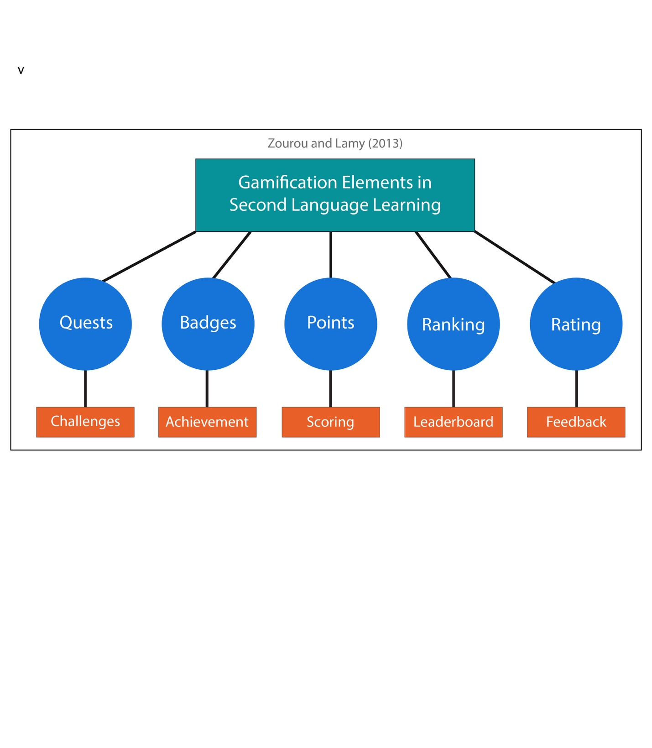Gamification in Language Learning utilizes game elements and systems into a non-game related education context (Johnson, 2013). With improvement in technology, gamification be applied to Mobile Assisted Learning through devices like the tablets, smartphones, and most commonly laptops/computers. As mentioned in the background section, gaming elements include in-game rewards, levels, quests, leaderboards, achievements, etc. The main goals of using these game elements is to immerse the students within the activity which increases motivation and engagement with the learning material (Csíkszentmihályi, 1990).

Figure 2.1 *- Gamification Elements (Zourou and Lamy, 2013)*

As shown in Figure 2.1, there are five core mechanisms when applying gamification to second language learning according to language researchers Zourou and Lamy (2013). These elements include quests, achievements, point systems, ranking, and rating systems. Quests, or “challenge” are in-game tasks that must be completed. These goals can either be achieved individually or within a group. In a secondary language e-learning environment, quests can be written or oral assignments in sentence structure or vocabulary. Achievements or “badges” are small graphical rewards that keep track of the students’ goals and challenges. These are often awarded after completing tasks and will be displayed in their profile for everyone to see. For example, once a student completes their daily tasks for the week, their profile will show a badge showing their achievements for that week. Points, or “scoring systems,” is the main currency of gamification. Students receive in-game points each time they participate or complete a task. For example, each time a student completes their homework or scores well on a test, then they will receive more points. The ranking, or “leaderboard system,” then determines the high achievers, or people with the most points and ranks them at the top within the list of students. These can be localized within a certain geographical location or it can expand globally with everybody participating. Lastly rating systems are placed to receive human feedback regarding the student, teacher, and the course material. This is a subjective strategy to assess the quality and the effective of the gamification model.

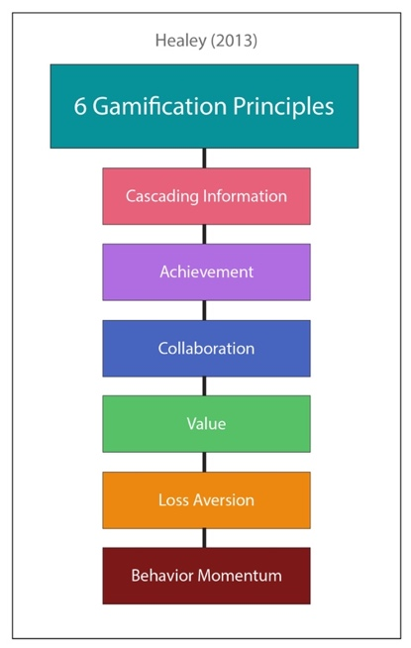

Figure 2.2 *Gamification Principles (Healey, 2013)*

The TESOL International Association summarizes six of the most common gamification principles when applied to their English teaching as shown in Figure 2.2 (Healey, 2013). The first principle is Cascading Information where information is broken up into smaller chunks for the students to consume. This prevents students to be overloaded with information and thus unable to comprehend the course material. For example, instead giving the entire study material for one chapter in a book, gamification can divide this into several different segments, pausing with either a quiz or achievement before moving on to another segment. This method helps students to focus the task at hand instead of being too distracted with the overall lesson.

The second principle is Achievements where students know they have completed a task and they are aware of it. People can be motivated by achievement as it can be one form of validity of their capabilities or their superiority from their peers. In a gamification, welcoming graphics, jingles, and words of encouragement are all strategies to validate the user’s achievement for completing the task. For example, each time, the student correctly answers a question, there will a nice smoothing ringtone. With this, it will a create a positive reinforcement for the students to continue achieve high standards.

Third principle is community collaboration where people form groups in order to complete a task. Collaborations can ease the task at hand by sharing the workload and even motivate students who like to socialize. For example, a forum is a good tool for users to learn from each other as people can ask their questions their can get answers from other students who are taking the same course. Another method is to assign group projects with bigger and harder tasks. Having collaborations within learning provides accountability that helps students do their respective jobs well.

The fourth principle is points or values given for the student’s actions. These points serve as progress marks that the students can refer back to see how they are doing with the game. For example, users usually start at zero points. As they progress through the lesson, they will gradually see their points rising. This can give them The fifth principle is loss aversion or avoiding penalties. In game, the losers are punished for their loss and this principle states that not wanting to receive a penalty can be a motivator for players. The sixth principle of gaming principle is behavior momentum. This is the human habit of once we enjoy something, we will continually repeat the activity. This principle states that the game must engage with the players in order for them to be hooked and to keep playing the game.

**2.2 Personalized Learning**

Personalized learning creates a curriculum that adapts to the input and interest of students using an intelligent learning system such as AI, data mining, or other context-aware tools. In this type of learning all the resources such as the teachers, peers, and content, are all readily and flexibly available to the students’ learning needs. There are three main aspects of personalized learning (Wong, 2016). The first factor is Individualized Difference in Learning where different students takes different methods and time to acquire a language skill. Here it is important not just what is being learned but how it is being learned also by the individual. The second factor is predictors of learning. These predictors range from genetics, growing environment, mental health, and working memory. Lastly and most importantly is to use the predictors to optimize a learning paradigm for the students. Here it is important to understand that different learning strategies can still meet education and behavioral goals when personally catered to an individual.

**2.3 Motivation Measurement**

An established theory to measure motivation within the e-learning context is proposed by John Keller (2008). Keller proposes the ARCS model that defines the four aspects of motivation for learners.

* The first A stands for attention or how attractive is the learning material in order to incite curiosity and attention for the user.
* The second R stands for relevance, which refers to the relation between the learning material and real-life scenarios. Here the focus to create learning within the context of the individual to self-determination and intrinsic goal orientation.
* The third C stands for confidence or the student’s perception on his ability to learn and complete the material.
* The four S stands for satisfaction or how positive the learners feel after completing the material.

Keller also adds a fifth principle which is Volitional or self-regulatory principle. Here, it is the motivation that allows the learner to continue and persist in his learning.

**2.4 Related Works**

The most influential Mobile Language Learning Application currently is *Duolingo*. *Duolingo* is a free platform that teaches language through the means of gamification. Even in 2016, it provided almost 60 language courses in 23 different languages (Huynh D, 2016). The model incorporates basic gamification principles which was discussed earlier. The first is achievement where users are awarded “lingots,” or in-game currency, as they complete a course material. These lingots are can be spent on their virtual shop in order to gain better lessons and customization capabilities. Moreover, they also award special badges or tokens when they have shown their capable skills. Secondly the model incorporates the principle of behavior momentum by having a level-system that tracks the students’ daily activities and achievements. As students can see their levels increase, it creates motivation for them to continue using the application in order to reach higher levels and goals. Particularly *Duolingo* provides experience points (XP) as a means to increase one’s level and these can be achieved by using the application frequently. Lastly, *Duolingo* incorporates the principle of loss aversion by having a leaderboard system. When players are ranked high, they don’t to lose their top-ranking spot which makes the application more fun and addictive for users in order to maintain their top rankings.

The basic interface of *Duolingo* consists of a language course that focuses on vocabulary and short phrases of the language through the use of simple multiple choice and fill in the blanks. However, it is still lacking in its effectiveness to learn speaking skills as it is often a one-directional learning or the absence of a dynamic teacher. Also, the program covers only basic entry-level materials without a linear progression in their lesson plans. The paper will discuss how the gamification model can be improved from the current *Duolingo* model.

Researchers from Budapest Business School, conducted the effectiveness of their Mobile Assisted Language Learning (MALL) project *busuu* with three main criteria: Performance, Motivation, and Feedback (Ketyi, 2016). To measure performance, they conducted two tests on the material: pre-test and post-test results. Pre-test are placement tests are taken by students prior to the MALL project and Post-test are results of how much they have improved or decreased om their tests. They also gave the students a questionnaire regarding their motivations on learning the course material both prior and after the research was conducted. The questions were categorized into five groups: the benefits of language learning, impressions on learning a new language, outside forces that influenced their language learning motivation, and finally their commitment to spend time learning the language. Then the two results will be compared to understand their effectiveness. Lastly, the researchers measured their feedback, or the students’ satisfaction regarding their MALL. Students filled out a questionnaire related to Strengths and Weaknesses of the program and their initial reactions. These questionnaires were given out twice: once shortly after they used the program and twice again after a couple of months into the program. In this research, I will use these same three measurements (performance, motivation, and feedback) to objectively assess the effectiveness of the gamification within the current mobile language learning applications.

Researcher Garrido and his team developed an architecture that uses AI planning and Case Base Planning to create a personalized educational learning route that caters to students’ needs (2016). The model has 4 different components. The first is an authoring tool to define the course. This tool will extract metadata information from the huge database to select a course. Then a Translator Module will compile all the PDDL files such as the domain and the problem. Then using Case Base Planning, it will solve the problem and create an initial lesson plan or even adapt to an existing plan based on merging techniques. The plan will be validated by a human teacher before it manifests itself in Learning Management Systems (LMS). The system will always monitor and check the progress to check for discrepancies and will execute another CBP accordingly.

The Personalized Creativity Learning System (PCLS) uses Data Mining technique specifically decision tree to optimize learning for students (Lin, 2013). This Personalized Creativity Learning System uses four agents to mine learning information. The User Interface Agent first collects information that the student provides during registration. Then a Path Agent will assign a learning path to a learner at random. After several interactions with the random Path Agent, a Creativity Game Agent will create a game-based activity and scenarios that will be recorded in the Learning Profile Database. Finally, the Questionnaire Agent will use tree algorithm and feature selection to optimize learning results based on the Learning Profile Database from the Creativity Game Agent.

In his personalized gamified model, Ku created a gamified learning activity that users can customize accordingly (Ku, 2016). He assigned a toolbar on the bottom of the screen to change game elements according to user preferences. The three aspects that the user was able to change was first the Narrative. Having a narrative engages the user more by evoking curiosity and imagination through a story. Secondly, there was an option to display hints. His researched showed that students who had specific detailed hints were better than general hints and hints are a great way for students to not give up when they are currently stuck at a problem. Lastly, he had the option to play music during the learning process as the selection of music can increase the learner’s enjoyment and reduce the tension and anxiety of learning.

Currently, there exists individually separated models that incorporates only either the gamification model or personalized learning model in e-learning. Even the one model that combined the gamified personalized system is still novel and offer only a few customization tools. This thesis will further discuss on the research method to create a more practical and effective e-learning model.

**Chapter 3**

**Research Methodology**

**3.1 Conceptual Framework**

From the literature study and theoretical frameworks, we can conclude that the design of e-learning systems impacts the effectiveness of the learner. Thus, in this analysis, the independent variables will be the different models of e-learning such as the gamification model, personalized model, and the hybrid model. The dependent variables will be the performance and motivation of the students. Within the dependent variable, learner’s motivation and achievement will be assessed. Through an ARCS motivation questionnaire, we will measure the motivation of the learning method and through test results and quizzes, we will assess whether the different models have significant impact on the learner’s language skills. In order to prove that one model is more effective than the others we need to observe which model has the overall highest score in the areas of learning performance, motivation, and feedback. It is also important to keep some variable constants such as similar test subjects, time, location, and environment.

There are three main hypotheses within this study related to our research questions and purpose:

H1: The Hybrid Model will affect students’ motivation.

H2: The Hybrid Model will affect students’ achievements.

H3: There is a correlation between students’ motivation and achievements.

The hypothesize that the hybrid model will perform the best in both motivation and achievement compared to other models as it provides an additional layer of intrinsic motivation and engagement which will result in higher performance and learner’s motivation. This is because the gamification model by itself relies heavily on external motivation and rewards, and thus when these things are taken away, it will have a detrimental impact on student’s learning experience. However, with the added personalized learning layer, it will enable students to have ownership of the course material and create self-determination to continue learning because of greater motivation.



*Figure 3.1 - Research Stages*

**3.2 Research Stages**

Research stages are shown in Figure 3.1, and it follows a linear process in from start to finish. The problem has been identified in Chapter 1 about the lack of intrinsic motivation within the current model of gamified language e-Learning. Then in Chapter 2, theories and methods regarding current gamified learning models are discussed. In Chapter 3, a Hybrid model of e-Learning is proposed that combines concepts of gamification and personalized. In the testing of the hypothesis that the hybrid model produces greater motivation and test results, different variables are considered. Independent variables will be the different models such as the gamification model, personalized learning model, and the hybrid model. The dependent variable will the measurement of the student’s motivation and achievement. To measure the achievement data, an average of the students’ quiz scores will be documented. For the motivation, a questionnaire will be given to analyze whether the hybrid model produced better results than the other two models. Then finally after the research is conducted, report will be written on the outcome of the experiment and future references for improvements on the study and the experiment.

**3.3 Proposed Model**

The Hybrid Model will be utilized as a web-based online language course that is both compatible to PCs and mobile devices. The web application will be created using a combination of MySQL, PHP, HTML, and CSS. The Hybrid Model will include both aspects of gamification and personalized learning as proposed in the thesis.

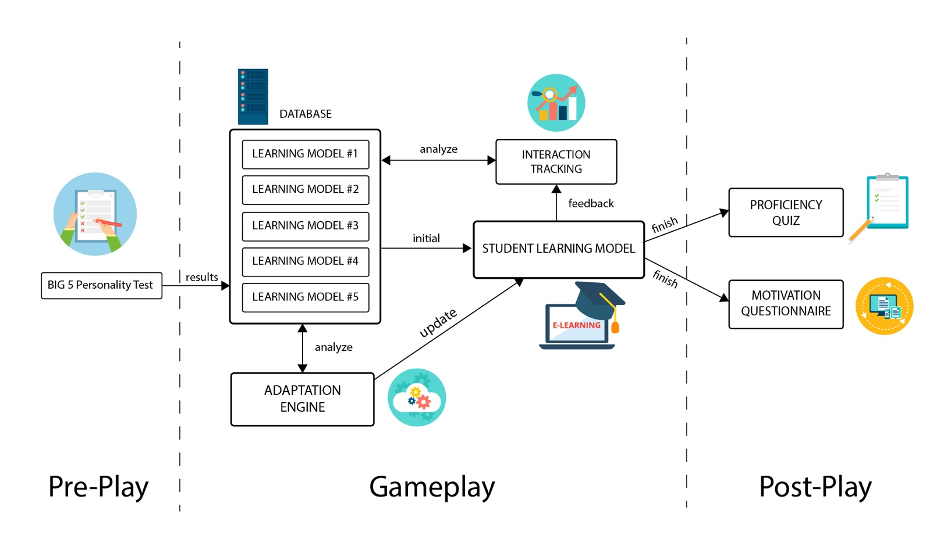

Figure 3.2 – Hybrid Model System Flow

As shown in Figure 3.2, students will first take a personality test prior to learning in order to match their personality with different learning sites. This is because there is a direct relationship between the learner’s personality and the preferred learning styles. We will be using the Big Five Personality Trait personality type indicator which will result in five initial different personality types (Costa & McCrae, 1992). These 5 different models will be entered into a database machine which will produce various gamification elements accordingly as they take the course as shown in Table 1. For example, a personality with openness enjoys adventure and trying new things, therefore providing gamification elements such as role-playing and in-game exploration will greatly increase their learning motivation. Contrarily, a person with a high neuroticism personality, frequent hints and difficulty adjustment will help relieve their stress when the learning gets too difficult.

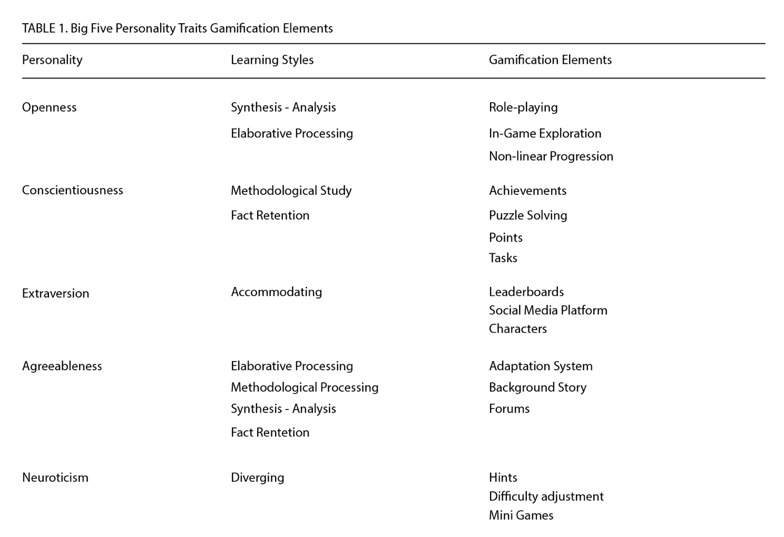

Once the learner’s learning style have been predetermined, the interaction tracking system will keep track of the students’ learning styles as they go through the course. This It will trace the inputs while learning into a database which will be sent off to an analysis system that will calculate user’s preferences and engagement. Then an Adaptation Engine will detect low engagement areas and updates the hybrid model for learners that are more suited with their preferences.

In addition to the default learning exercises, students have the ability to input their own vocabulary words into the system’s database. Students can choose which vocabulary words and examples sentences they want to learn. For example, when they read a book and stumble upon a word that they don’t know, they can find the definition and input the example sentences straight from the book to have it personalized to what they have already read in the book. This will improve memory recall as the student now has ownership of what they are learning. Moreover, using database indexing, the system will rank which words the students’ constantly get wrong and display them at the top of the word list for real-time feedback on their performance. Both of these metrics will be evaluated to determine the overall effectiveness of the Hybrid Model.

In terms of gamification, much like Duolingo, students will be given assignments depending on their preferred learning styles. For example, some learners prefer the complete vocabulary recall tasks one at a time while others learn better by discussing the meaning of these words with peers. For example, the task will display a word used within a sentence and the student’s goal is to type in the foreign language word in their keyboard or they can select pictures related to the word if they are visual learners. Once completing their learning exercises, students will have the chance to play a spin-the-wheel to earn points for themselves. Students can then accumulate these points in exchange for physical rewards such as books, electronics, vouchers, etc. For personality types who enjoys competition, a leaderboard and ranking system will be implemented for increase motivation. Any of these gamification elements have the option to be turned off by the learners if they wish to.

**3.4 Evaluation**

The evaluation will take place by high-school students in Tangerang for a month-period. To confirm our hypothesis, we need to divide into two groups: the test group (with the hybrid model) and control group (without the hybrid model). Both groups will take weekly vocabulary quizzes from the same book except the test group can input their own vocabulary words as they read while the control group already have words given to them to memorize. The constant variable will be the gamification element or the spin-the-wheel reward at the end of each assignment. Numeric Data (test scores) will be collected from both groups to get the students’ average scores every week. Then using Parametric Statistics, we will determine p-value and the average differences to either nullify or confirm the hypothesis that the hybrid model does improve the students’ learning. To measure motivation, a questionnaire will be given at the beginning and the end of the experiment as shown in Table 2. Similar to the ARCS model, the questionnaire will include 1-5 Lichert scale, 5 meaning “strongly agree,” to 1 being “strongly disagree,” on attention, relevance, confidence, satisfaction by the students on the program. Then the average mean will be recorded and compared to see whether their motivation decrease or increase overtime using 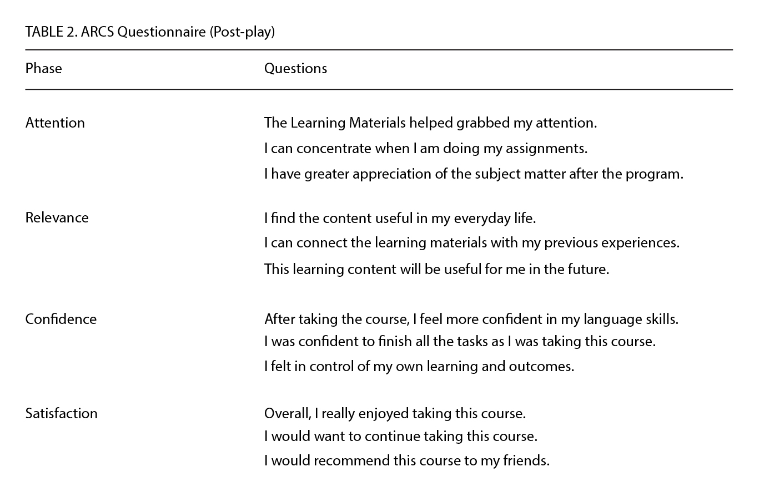the program.

Collection of Data will include both aspects of subjective data and objective data. Subjective data will include a feedback questionnaire and motivation from users while objective data measurements will include the effectiveness of the model by comparing the quiz scores at the end of the program. Data will be collected and recorded in an online database for a month-period which will be then used to find the mean or the average of collected data.

**3.5 Statistical Data Analysis**

The ARCS questionnaire used in this experiment was based on the Keller’s motivation model that are often used within the context of instructional assignments. Thus, we modified the survey to create a motivation scale for secondary language learning. The questionnaire touched on each of the four major aspects with three questions each on a 1-5 Likert scale. To make sure the survey and the responses are reliable, we will later test the Cronbach’s alpha value for internal consistency reliability. If the alpha value is greater than or equal to 0.7 then the survey and its subscale will be considered reliable (Nunnaly, 1978). To validate the ARCS motivation questionnaire, we established a face validity by replicating similar questions conducted in another related research study (Su, 2014).

To confirm or deny H1 and H2, we will first create a null and alternative hypothesis for each of the hypotheses:

* H1: The Hybrid Model will affect students’ motivation.

Null Hypothesis (H0): The mean ARCS motivation score from the “hybrid model” and the “non-hybrid models” is the same.

Alternative Hypothesis (HA): The mean ARCS motivation score from the “hybrid model” and the “non-hybrid models” are not the same.

* H2: The Hybrid Model will affect students’ achievements.

Null Hypothesis (H0): The mean quiz scores of students from the “hybrid models” and the “non-hybrid models” is the same.

Alternative Hypothesis (HA): The mean quiz scores of students from the “hybrid models” and the “non-hybrid models” is different.

Then using Parametric Statistics using R through t-test, we will find the p-value or the level of statistical significance of both hypotheses assuming that the null hypothesis is true. When p < 0.05, it becomes statistically significant, and we can reject the null hypothesis and accept the alternative hypothesis, or the hybrid model has significant impact of students’ learning and motivation accordingly.

To confirm or deny H3, we will be using the Pearson Correlation Coefficient formula to find the correlation coefficient to check whether students’ motivation has a positive impact on their achievements and vice versa. The coefficient value will result anywhere from -1.00 to 1.00. If the coefficient value is within the negative range, then we can deny that there is an inverse relationship between students’ motivation and achievements (as one increases, the other decreases) but if the coefficient value is within the positive range, then we can confirm that students’ motivation and achievements are positively correlated (as one increases, so does the other, and vice versa.) If the coefficient value is close to zero, then there is no association between student’s motivation and achievements.

**References**

Brown,T. H., Mbati, L. S. (2015). Mobile learning: Moving past the myths and embracing the opportunities. International Review of Research in Open and Distributed Learning, 16(2),115-135.

Costa, P. T., & McCrae, R. R. (1992). NEO PI-R: Professional Manual: Revised NEO PI-Rand NEO-FFI. Florida: Psychological Assessment Resources, Inc..

Csikszentmihalyi, M. (1990). *Flow: e psychology of optimal experience*. New York: Harper & Row.

Cunningham, S. J., Scott, L., Hutchison, J., Ross, J., & Martin, D. (2018). Applying Self-Processing Biases in Education: Improving Learning Through Ownership. *Journal of Applied Research in Memory and Cognition,* *7*(2). doi:10.1016/j.jarmac.2018.04.004

Healey, D. (2013). Gamification for EL teachers. TESOL. Retrieved from https://www.tesol.org/connect/tesol-resource-center/search-details/teaching-tips/2013/11/19/gamification-for-el-teachers

Humphreys, G. W., & Siu, J. (2016). Attentional control and theself: The self-attention network (SAN). *Cognitive Neuroscience*. http://dx.doi.org/10.1080/17588928.2915.1044427

Huynh D., Zuo L., Iida H. (2016) Analyzing Gamification of “Duolingo” with Focus on Its Course Structure. In: Bottino R., Jeuring J., Veltkamp R. (eds) Games and Learning Alliance. GALA 2016. Lecture Notes in Computer Science, vol 10056. Springer, Cham

J. M. Keller, “First principles of motivation to learn and e 3 ‐learning,” Distance Educ., vol. 29, no. 2, pp. 175–185, 2008.

Johnson, L., Adams, S., Cummins, M., Estrada, V., Freeman, A., & Ludgate, H. (2013). NMC horizon report: 2013 higher education edition. Austin: The New Media Consortium. Retrieved from: https://www.nmc.org/system/files/pubs/1359993875/2013-horizon-report-HE.pdf (08 July 2018).

Ketyi, A., 2016. From Mobile Language Learning to Gamification: An Overlook of Research Results with Business Management Students over a Five-Year Period. Porta Linguarum, pp. 45-60.

Khan, Asharul & Alshihi, Hafedh & Al-Khanjari, Zuhoor & Sarrab, Mohamed. (2015). Mobile Learning (M-Learning) adoption in the Middle East: Lessons learned from the educationally advanced countries. Telematics and Informatics. 32. 909-920. 10.1016/j.tele.2015.04.005.

Kim, K., & Ahn, S.J. (2017). The Role of Gamification in Enhancing Intrinsic Motivation to Use a Loyalty Program. *Journal of Interactive Marketing*, 40, 41-51. doi: 10.1016/j.intmar.2017.07.001

Ku, O., Hou, C., & Chen, S. Y. (2016). Incorporating customization and personalization into game-based learning: A cognitive style perspective. *Computers in Human Behavior,* *65*, 359-368. doi:10.1016/j.chb.2016.08.040

Lin, C. F., Yeh, Y., Hung, Y. H., & Chang, R. I. (2013). Data mining for providing a personalized learning path in creativity: An application of decision trees. *Computers & Education,* *68*, 199-210. doi:10.1016/j.compedu.2013.05.009

Mayer, R. E. (2009). Multimedia learning (2nd ed.). Cambridge: Cambridge University

Press.

Moller, L., & Soles, C. (2001). Myers Briggs type preferences in distance learning

education. International Journal of Educational Technology, 2(2).

Myers, B., & McCaulley, M. H. (1985). Manual: A guide to the development and use of

the myers-briggs type indicator. Palo Alto, CA: Consulting Psychologists Press.

Nunnaly, J. (1978). Psychometric theory. New York: McGraw-Hill.

Ogata, H., & Yano, Y. (2005). Knowledge awareness for computer-assisted language learning using handhelds. International Journal of Learning Technology, 5(1), 435-449. Pedro, L. F., Cláudia Marina Mónica de Oliveira Barbosa, & Santos, C. M. (2018, March 15). A critical review of mobile learning integration in formal educational contexts. Retrieved July 1, 2018, from https://link.springer.com/article/10.1186/s41239-018-0091-4#citeas

Park, H., & Bae, J. (2014). Study and Research of Gamification Design. *International Journal of Software Engineering and Its Applications,* *8*(8), 19-28. doi:10.14257/ijseia.2014.8.8,03

Reichelt, M., Kämmerer, F., Niegemann, H. M., & Zander, S. (2014). Talk to me personally: Personalization of language style in computer-based learning. Computers in Human Behavior, 35, 199-210. doi:10.1016/j.chb.2014.03.005

Su, C., & Cheng, C. (2014). A mobile gamification learning system for improving the learning motivation and achievements. *Journal of Computer Assisted Learning,31*(3), 268-286. doi:10.1111/jcal.12088

Turk, D. J., Gillespie-Smith, K., McGowan, L., Havard, C., Conway, M.A., Krigolson, & Cunningham, S. J. (2015). Selfish learning: Theimpact of self-referential encoding on children’s literacy attainment. *Learning & Instruction*, *40*, 54–60.

Wong, P. C., Vuong, L. C., & Liu, K. (2017). Personalized learning: From neurogenetics of behaviors to designing optimal language training. *Neuropsychologia,* *98*, 192-200. doi:10.1016/j.neuropsychologia.2016.10.002

Zourou, K., & Lamy, M. (2013). Social networked game dynamics in web 2.0 language learning communities. Alsic, 16. Retrieved from http://alsic.revues. org/2642. doi:https://doi.org/10.4000/alsic.2642